Estimated Technical Safety Concept
Project name: MVC SOW2
Version: A04
Status: Draft
Date: 19.12.2025
Author: U. Grüner

Printed copies of this document are not subject to document control!
Table of Contents
1. General information 9
1.1 Purpose of this document 9
1.2 Scope 9
2. Contextual Framework 10
2.1 Ambarella Safety Architecture 11
2.2 What is not covered by the Ambarella safety concept? 13
2.3 HW safety functions and Top-Level view of software architecture 13
2.4 iSafety (Cortex R52) 15
2.5 SOW1 Interface 17
3. Estimated Technical Safety Concept 17
3.1 Technical Safety Strategy 17
3.2 Definition of Safe State 18
3.2.1 SOW2 indication of safe state 19
3.2.2 Technical Notes 20
3.3 BIST 20
3.3.1 Technical Notes 20
3.3.2 BIST TSR 21
3.4 SOW1 (Sensor) 22
3.4.1 Technical Notes 22
3.4.2 SOW1 related TSR 23
3.5 Clocks 24
3.5.1 Technical Notes 24
3.5.2 Clocks TSRs 24
3.6 Power 24
3.6.1 Technical Notes 24
3.6.2 Power TSRs 25
3.7 Temperature Monitoring 25
3.7.1 Technical Notes 25
3.7.2 Temperature Monitoring TSRs 25
3.8 SG1 (Latency) 25
3.8.1 Technical Notes 26
3.8.2 SG1 TSRs 27
3.9 SG2 (Live, not frozen) 28
3.9.1 Technical Notes 29
3.9.2 SG2 TSRs 29
3.10 SG3 (Unclear view) 30
3.10.1 Technical Notes 30
3.10.2 SG3 TSRs 31
3.11 SG4 (Angle of view) 31
3.11.1 Technical Notes 32
3.11.2 SG4 TSRs 32
3.12 Ethernet PHY 32
3.12.1 Ethernet PHY TSRs 33
3.13 DDR4 33
3.14 Interface towards vehicle 33
3.14.1 Technical Notes 33
3.14.2 Vehicle Interface TSRs 33

List of figures
Figure 1: ISO 26262 10
Figure 2: Microcontroller with safety mechanisms and ASIL allocation 12
Figure 3: CV22FS HW Safety Function 14
Figure 4: Top-Level Software Architecture and Safety Concept 15
Figure 5: System Overview iSafety 16
Figure 6: Dynamic View - Data Flow 18

List of tables
Table 1: Change History 6
Table 2: Releases 6
Table 3: Template Version 6
Table 4: Authors 6
Table 5: Referenced Documents 8
Table 6: List of Abbreviations 8

Change history
Ver. | Author | Description / Change / Comments | Date
A01 | Uwe Grüner | 1st draft | 04.09.2025
A02 | Oliver Jaeschke | Changed text an picture in sec. 2;
A03 | Uwe Grüner | Rework after first review | 11.12.2025
A04 | Uwe Grüner | Rework after review discussion | 19.12.2025
Table 1: Change History
Releases
Ver. | Created / Date | Signature | Approved / Date | Signature | Released / Date | Signature
Table 2: Releases
Template history
Ver. | Created / Date | Signature | Approved / Date | Signature | Released / Date | Signature
A | 23.06.2020 | {S.Schuetz} | 24.06.2020 | {O.Jaeschke} | 25.06.2020 | {S.Schuetz}
B | 27.08.2021 | {O. Jaeschke} | 27.08.2021 | {S.Schuetz} | 27.08.2021 | {S.Schuetz}
C | 11.01.2022 | {O. Jaeschke} | 18.02.2022 | {S.Schuetz} | 18.02.2022 | {S.Schuetz}
Table 3: Template Version
Authors
Section | Name | E-Mail | Telephone
All | Uwe Grüner | uwe.gruener@solectrix.de | +49 (0) 911 - 30 91 61 - 276
Table 4: Authors
Referenced documents
No. | Title & Description | Version | Author | Link
[1] | ISO 2626 | 2018 | Multiple | S:\opendocs\spezifikationen\Normen\FuSi\ISO 26262-2018
[2] | Rear and Trailer Camera TR – 24548584 | v1 | Volvo Trucks Corporation | https://erg-polarion-p1.mekra.net/polarion/#/project/11_P_01467_MEKRA_Vision_Controller/wiki/10_Customer_Requirements/Rear_and_Trailer_Camera_Software_TR_24560666_v1
[3] | HW-SM-002_0.8_Ambarella CV2FS CV22FS HW Safety Manual.pdf | rev. 1522576 | Ambarella, Inc. | https://erg-polarion-p1.mekra.net/polarion/svnwebclient/fileContent.jsp?url=Intern%2F11_P_01467_MEKRA_Vision_Controller%2FProject%20Files%2F02%20Development%2FAmbarella-Docs%2FTEMP_PRO_98413_SOLECTRIX%2FHW-SM-002_0.8_Ambarella%20CV2FS%20CV22FS%20HW%20Safety%20Manual.pdf
[4] | CV22FS-S03-002_1.2_Ambarella CV22FS Hardware Programming Reference Manual.pdf | Version 1.2 | Ambarella, Inc. | https://erg-polarion-p1.mekra.net/polarion/svnwebclient/fileContent.jsp?url=Intern%2F11_P_01467_MEKRA_Vision_Controller%2FProject%20Files%2F02%20Development%2FAmbarella-Docs%2FTEMP_PRO_80237_SOLECTRIX%2FCV22FS-S03-002_1.2_Ambarella%20CV22FS%20Hardware%20Programming%20Reference%20Manual.pdf
[5] | SW-SM-004_0.3_Ambarella CV22FS CV2FS SDK Top Level Software Architecture.pdf | rev. 426409 | Ambarella, Inc. | https://erg-polarion-p1.mekra.net/polarion/svnwebclient/fileContent.jsp?url=Intern%2F11_P_01467_MEKRA_Vision_Controller%2FProject%20Files%2F02%20Development%2FAmbarella-Docs%2FVorablieferung-Dokumente%2FSW-SM-004_0.3_Ambarella%20CV22FS%20CV2FS%20SDK%20Top%20Level%20Software%20Architecture.pdf
[6] | CV2FS SDK8 Application Note (AN) SVC iSafety | Version 1.2 | Ambarella, Inc. | https://erg-polarion-p1.mekra.net/polarion/svnwebclient/fileContent.jsp?url=Intern%2F11_P_01467_MEKRA_Vision_Controller%2FProject%20Files%2F02%20Development%2FAmbarella-Docs%2FTEMP_PRO_74644_SOLECTRIX%2FSDK8-AN-008_1.2_Ambarella_CV2FS_SDK8_AN_SVC_iSafety.pdf
[7] | S5K3B6SX_Data Sheet_Preliminary_ALL_REV 0.01-Mekra.pdf | Revision 0.01 | Samsung Electronics | https://erg-polarion-p1.mekra.net/polarion/svnwebclient/fileContent.jsp?url=Intern%2F11_P_01467_MEKRA_Vision_Controller%2FProject%20Files%2F02%20Development%2FDatasheets%2FSOW1%2FS5K3B6SX_Data%20Sheet_Preliminary_ALL_REV%200.01-Mekra.pdf
[8] | S5K3B6SA_Application Note_ALL_REV 0.03_Preliminary.pdf | Revision 0.03 | Samsung Electronics | https://erg-polarion-p1.mekra.net/polarion/svnwebclient/fileContent.jsp?url=Intern%2F11_P_01467_MEKRA_Vision_Controller%2FProject%20Files%2F02%20Development%2FDatasheets%2FSOW1%2FS5K3B6SA_Application%20Note_ALL_REV%200.03.pdf
[9] | Functional Safety Concept | Tbd. | MekraLang/Solectrix | https://erg-polarion-p1.mekra.net/polarion/svnwebclient/fileContent.jsp?url=Intern%2F11_P_01467_MEKRA_Vision_Controller%2FProject%20Files%2F02%20Development%2FFunctional%20Safety%2FFunctional_Safety_Concept.docx
[10] | S08-371_1227_Ambarella_SDK8_SVC_iCAM_VinVoutErrCtrl.pdf | 1227 | Ambarella, Inc. | https://erg-polarion-p1.mekra.net/polarion/svnwebclient/fileContent.jsp?url=Intern%2F11_P_01467_MEKRA_Vision_Controller%2FProject%20Files%2F02%20Development%2FAmbarella-Docs%2FTEMP_PRO_74644_SOLECTRIX%2FSW-S08-371_1227_Ambarella_SDK8_SVC_iCAM_VinVoutErrCtrl.pdf
[11] | TJA1104 safety manual, UM12054  TJA1121 safety manual, UM12165 | Rev. 1  Rev. 1.0 | NXP Semiconductors
[12] | Deserializer MAX96714 | 19-101134; Rev 1; 5/23 | Analog Devices | https://erg-polarion-p1.mekra.net/polarion/svnwebclient/fileContent.jsp?url=Intern%2F11_P_01467_MEKRA_Vision_Controller%2FProject%20Files%2F02%20Development%2FDatasheets%2FDeserializer%2Fdeserializer_max96714.pdf
[13] | Serializer MAX96717 | 19-100942;  Rev 6 3/35 | Analog Devices | https://erg-polarion-p1.mekra.net/polarion/svnwebclient/fileContent.jsp?url=Intern%2F11_P_01467_MEKRA_Vision_Controller%2FProject%20Files%2F02%20Development%2FDatasheets%2FSerializer%2Fserializer_max96717.pdf
[14] | TSR Deserializer.docx |  |  | https://erg-polarion-p1.mekra.net/polarion/svnwebclient/fileContent.jsp?url=Intern%2F11_P_01467_MEKRA_Vision_Controller%2FProject%20Files%2F02%20Development%2FFunctional%20Safety%2FDeserializer.docx
[15] | TSR_DDR4.docx |  |  | https://erg-polarion-p1.mekra.net/polarion/svnwebclient/fileContent.jsp?url=Intern%2F11_P_01467_MEKRA_Vision_Controller%2FProject%20Files%2F02%20Development%2FFunctional%20Safety%2FTSR_DDR4.docx
[16] | TSR_PHY.docx |  |  | https://erg-polarion-p1.mekra.net/polarion/svnwebclient/fileContent.jsp?url=Intern%2F11_P_01467_MEKRA_Vision_Controller%2FProject%20Files%2F02%20Development%2FFunctional%20Safety%2FTSR_PHY.docx
[17] | TSR_PMIC_MPQ70165FS.docx |  |  | https://erg-polarion-p1.mekra.net/polarion/svnwebclient/fileContent.jsp?url=Intern%2F11_P_01467_MEKRA_Vision_Controller%2FProject%20Files%2F02%20Development%2FFunctional%20Safety%2FTSR_PMIC_MPQ70165FS.docx
[18] | TSRs – Flash.md |  |  | https://erg-polarion-p1.mekra.net/polarion/svnwebclient/fileContent.jsp?url=Intern%2F11_P_01467_MEKRA_Vision_Controller%2FProject%20Files%2F02%20Development%2FFunctional%20Safety%2FTSRs%20-%20Flash.md
[19] | Functional Safety Requirement for HOST SYSTEM | Date: 2025-10-22  Revision: 17.2 | Bosch | https://erg-polarion-p1.mekra.net/polarion/svnwebclient/fileContent.jsp?url=Intern%2F11_P_01467_MEKRA_Vision_Controller%2FProject%20Files%2F02%20Development%2FFunctional%20Safety%2FCH3SVC_VT_ECU_RS_17v2_PRELIMINARY_20251022.pdf
[20] | TSC Vision Cameras – Camera | 0.0.3  2025-11-04 | Volvo | https://erg-polarion-p1.mekra.net/polarion/svnwebclient/fileContent.jsp?url=Intern%2F11_P_01467_MEKRA_Vision_Controller%2FProject%20Files%2F02%20Development%2FFunctional%20Safety%2FTSC%20Vision%20Cameras%20-%20Camera%20v%200_0_3.pdf
[21] | TimestampOverlay_Requirements | N/A | Volvo | https://erg-polarion-p1.mekra.net/polarion/svnwebclient/fileContent.jsp?url=Intern%2F11_P_01467_MEKRA_Vision_Controller%2FProject%20Files%2F02%20Development%2FFunctional%20Safety%2FTimestampOverlay_Requirements.pdf
Table 5: Referenced Documents
List of abbreviations
Abbreviation | Description
AoU | Assumption of Use
CEHU | Central Error Handling Unit
CON | Assumed Constraints
CPU | Central processing unit
FSC | Functional Safety Concept
FSR | Functional Safety Requirement
HW | Hardware
MCS | Mirror camera system for replacing glass mirrors
NFR | Assumed Non-Functional Constrained
ORC | OpenRISC Core
PMIC | Power Management IC
SEooC | Safety Element out of Context
SW | Software
TLSR | Assumed Toplevel Safety Requirement
TLSS | Toplevel Safe Sates
TSC | Technical Safety Concept
TSR | Technical Safety Requirement
Table 6: List of Abbreviations

General information
This document describes the estimated technical safety concept for the project MVC SOW2 of the customer MEKRA Lang according to the guidelines described in ISO 26262-4:2018 [1]. Subject of this project is the development of a camera-monitor system for trucks. For more details about the project please read the project manual.

Purpose of this document
This document is an estimation of Technical Safety Requirements and serves as input until Functional- and Technical Safety documents are finally in place.
It shall provide input to the technical safety concept and requirements regarding the functionality, dependencies, constraints and properties of the system elements and interfaces needed for their implementation. It further specifies possible technical safety requirements regarding the safety mechanisms to be implemented in the system elements and interfaces. The technical safety requirements are derived from the functional safety requirements (or to external measures), where FSR are available.
In addition, it provides hints for the Software safety requirements.

Scope
This document lists all relevant system components and their capability to implement functional safety requirements in the project MVC SOW2 – with the focus on a technical safety concept.
Regarding the technical scope, the MVC SOW2 can be composed into:
- Software
- Hardware
- HW-SW-Interoperation
For the responsibility of these SOW2 components, refer to the projects Development Interface Agreement (DIA).

It should be noted that the SOW1 and SOW2 Hardware are considered as separate but connected devices, but the SOW2-SW controls the combined SOW1 and SOW2 Hardware.
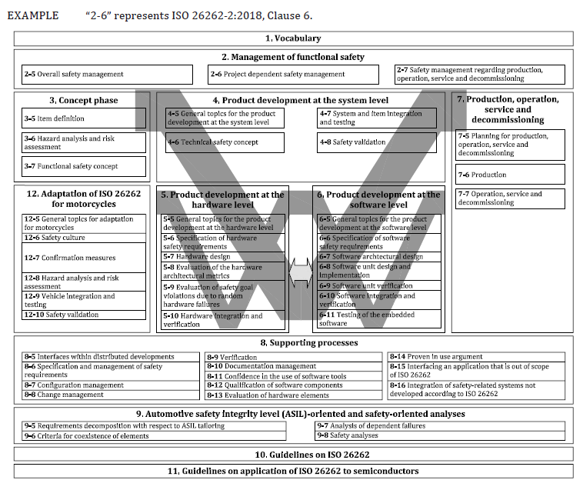
Figure 1: ISO 26262

Contextual Framework
This document describes the safe configuration, Assumptions-of-use for the SEooC and the applicable safety mechanism to be used for the system.

The system comprises several components, which shall be considered in a technical safety concept. These components are described in more detail with respect to technical safety in chapter 3.
- SOW1
- Clocks
- Power
- Temperature
- CV22FS85
- Deserializer
- Ethernet PHY
- DRAM

Safety-Faults from SOW1 are subject to be handled within SOW2 as described in [19] CH3SVC_VT_ECU_RS_17v2_PRELIMINARY_20251022.pdf

Regarding Cypersecurity Concept, it is assumed that this will be handled in a separate document and is not part of the Estimated Technical Safety Concept.

This chapter will give a shortened overview of how Technical Safety of CV22FS will work and points out where it doesn't apply. Details and technical descriptions for further reading can be found in the [3] HW-SM-002_0.8_Ambarella CV2FS CV22FS HW Safety Manual.pdf.

The items and concepts from [3] in the list below shall be read and understood:

- Operating Modes and Modes that support Safety
  - Description of operation modes and their relevance regarding safety
- TLSR: Assumed Toplevel Safety Requirements [TLSR-<number>]
  - Definition of assumed top-level safety requirements
- TLSS: Toplevel Safe States [TLSS-<number>]
  - Definition of top-level safe states and error indicator
- NFR: Assumed Non-Functional Requirements [NFR-<number>]
  - Environmental Conditions, Lifetime and Quality Requirements
  - Quantitative Analysis of Random Hardware Faults
- CON: Assumed Constraints [CON-<number>]
  - defines constraints and assumptions for the usage in a safety-related application
- AoU: Assumptions of Use [AR-<number>]
- CEHU: Central Error Handling Unit
  - consolidates all internal error sources
  - creates configurable error reactions, including safe state handling as defined in TLSS.

In general, the Technical Safety Concept applies as described [3] HW-SM-002_0.8_Ambarella CV2FS CV22FS HW Safety Manual.pdf, chapter 4.
- The System Integrator is responsible for ensuring that software functions (realized by Hardware and Software) executed on the Cortex A53 are safe.
- The System Integrator is responsible for configuring the necessary HW safety mechanism where applicable, cf. [3] HW Safety Manual and [6] Application Note (AN) SVC iSafety
- The System Integrator is responsible to fulfill the Assumptions-of-Use (AoU) as stated [3], chapter 5.3.
- The System Integrator is responsible for testing the integrated software and system functions at their respective ASIL rating.

Internal HW Errors are collected in the CEHU. Errors are propagated via safety error pin or Interrupt or both, when configured.
SW Errors can be reported to CEHU via SW Error Indication registers for consolidation.
Refer to chapter 2.4 iSafety (Cortex R52)

Both mechanisms need configuration, and the responsibility lies with the System Integrator.

Ambarella Safety Architecture

The used Ambarella CV22FS offers a set of safety mechanisms in Hardware to achieve the relevant ASIL level. C.f. [3] HW-SM-002_0.8_Ambarella CV2FS CV22FS HW Safety Manual.pdf, chapter 4.2.
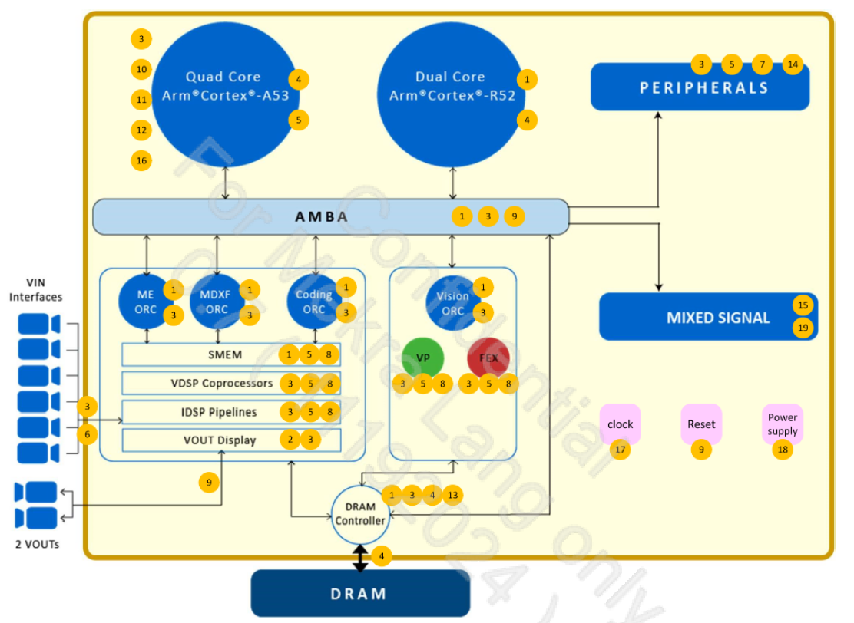
Figure 2: Microcontroller with safety mechanisms and ASIL allocation
The following major safety mechanisms are shown in Figure 2:
- Dual-core lockstep (DCLS)
- Duplicated logic (Hardware redundancy)
- Watchdog timer (or timeout mechanism)
- ECC
- Parity
- CRC or signature
- End-to-End (E2E) protection protocol
- Software Test pattern
- Software Register check
- Software Data Integrity check
- Software GIC checker (Interrupt monitor)
- Software Test Library (STL)
- Segmentation (Access protection)
- Hardware loop-back
- BuiIt-in self-test pattern (BIST)
- Performance monitor
- Clock monitor
- Power monitor (either internal or external)
- Voltage detector

Besides the Ambarella CV22FS built-in safety mechanisms, the system needs additional external safety mechanisms:
- Monitoring for power supply AVDD18, capable of triggering the safe state, cf. chapter 3.6 Power below.
- An external temperature sensor is needed, capable of triggering the safe state, cf. chapter 3.7 Temperature Monitoring below.
  - Note: The SEooC Temperature Sensor shall not be used for safety-related temperature monitoring, because it is only QM.
  - cf. [3], chapter 3.4, [CON-12]

What is not covered by the Ambarella safety concept?

- Cortex A53 (QM) is considered unreliable ([3] chapter 4.2, p. 18)
  - SW shall take measures to compensate for HW errors on Cortex A53
    - e.g. Watchdog (APB Watchdog Timer)
    - e.g. crosscheck on Cortex R52 to verify SW on Cortex A53
- Peripherals (QM), cf. [3], chapter 3.4, CON-5 to CON-10
  - JTAG
  - USB Interface
  - Ethernet Interface
  - I2S Interface
  - PWM Interface
  - SDIO Interface
  - UART Interface

HW safety functions and Top-Level view of software architecture

In Figure 3, c.f. SDK8 User Guide Introduction and Navigation Map, chapter 2.2.9, depicts the safety functions and their location in Hardware. It gives an overview which elements are SEooC and which elements need additional measures to fulfil the safety requirements.

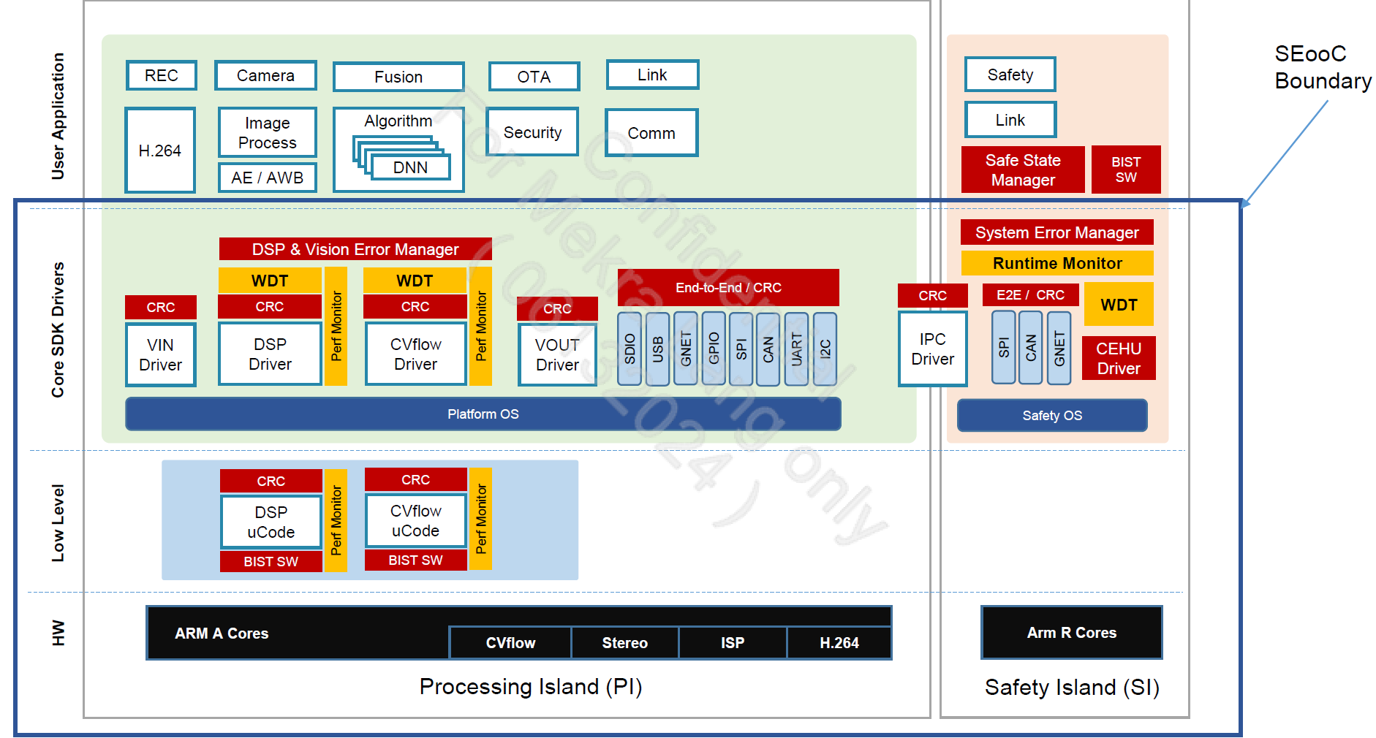
Figure 3: CV22FS HW Safety Function
While Figure 3 focuses on hardware safety functions, Figure 4 focuses on the Software Architecture and SEooC, which can be found in [5], chapter 2.2:
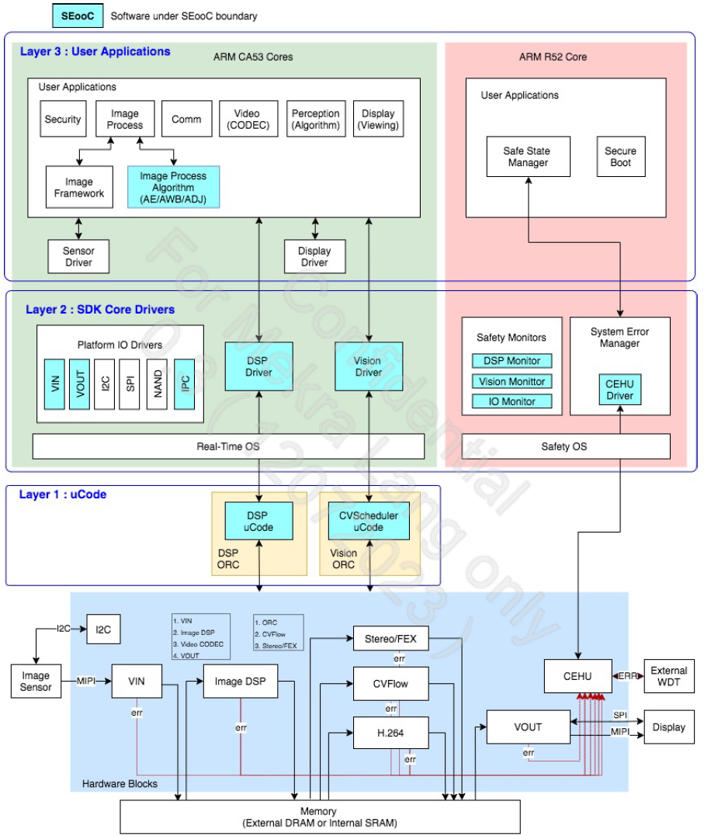
Figure 4: Top-Level Software Architecture and Safety Concept

iSafety (Cortex R52)

cf. [6] CV2FS SDK8 Application Note (AN) SVC iSafety
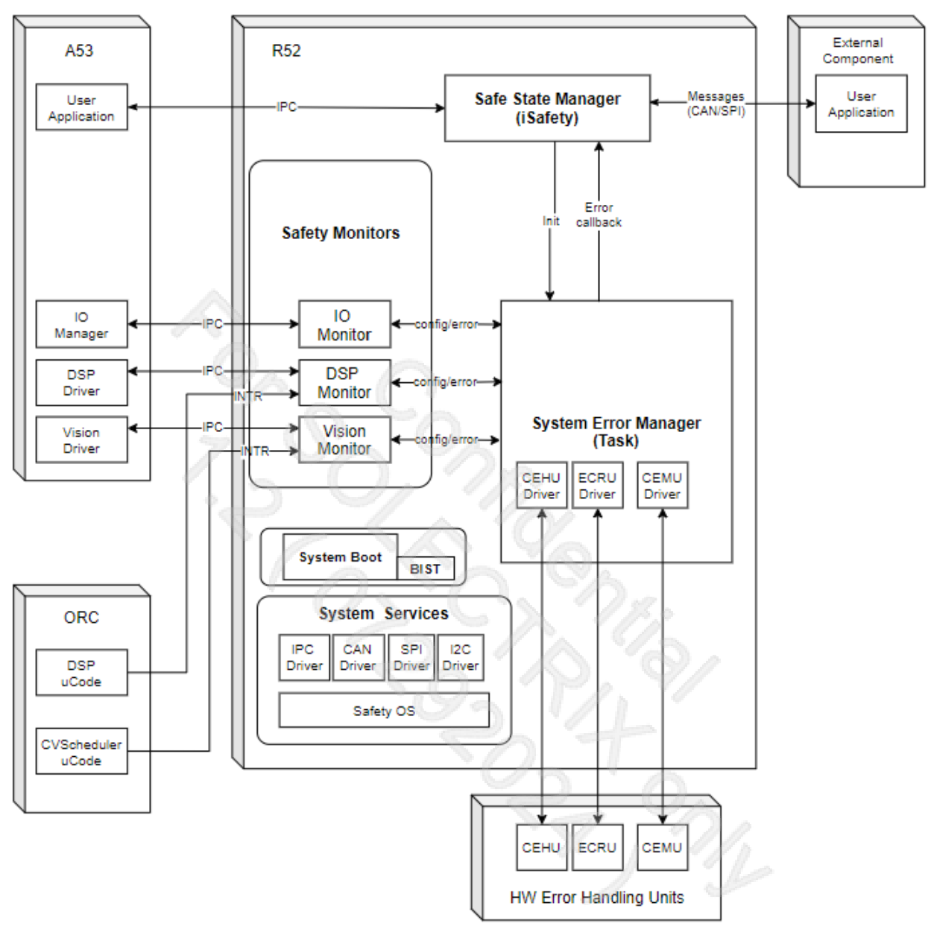
Figure 5: System Overview iSafety

The System Error Manager (SEMGR) is the software (SW) module on Cortex R52 managing most of the system’s safety errors.
When there are HW errors, the SEMGR will inform the R52 reference application, called “iSafety”.
The iSafety can communicate with the Cortex A53 reference application, iCam, through, Inter-Process Communication (IPC) and modules between R52 and A53.

Tasks:
- Inter Process Communication (IPC) with Cortex A53 (iCam)
  - iSafety <-> iCam
- Safe State Manager Task
- init IO-, DSP- and Computer Vision monitor
- init CEHU
- evaluate BIST result
- init clock monitors

SOW1 Interface

MVC-94043 - HSI - Camera Interface describes the interface between SOW2 and SOW1 via the deserializer MAX96714. The interface includes safety relevant signaling in the GPIOs as well as safety relevant information in the embedded data lines of the protocol.

GPIOs
- Inputs to SOW2:
  - imagerError
  - camPmicError
  - desError (from SOW2 deserializer)
- Output from SOW2:
  - camHeatingEn
  - imagerEN
  - desEn
  - powerOverCoaxEn
- I2C Interface between CV22FS and deserializer
  - ISP_DES_I2C.CLK
  - ISP_DES_I2C.DAT

For the technical safety relevant handling, refer to chapter 3.4.

Estimated Technical Safety Concept

Technical Safety Strategy

The item definition can be found in [9] Functional_Safety_Concept, chapter 2. The focus is on SOW2 only and defines:
- Image Acquisition (IA)
  - IA Data Path
  - IA Control Path
- Image Processing (IP)
  - IP Data Path
  - IP Control Path
- Image Output (IO)
  - IO Data Path
  - IO Control Path
- Power Management
- Diagnosis
- Ethernet SOME/IP

The picture below shows the Data Flow view of the used CV22FS. The video stream output is done via ENET (Ethernet Interface):
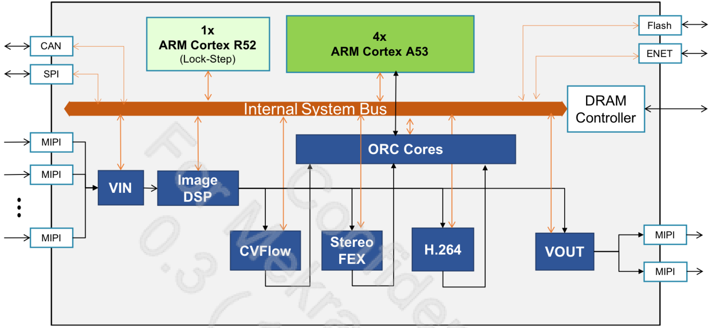
Figure 6: Dynamic View - Data Flow
Boundaries of the Items defined:

Item | Boundaries
Image Acquisition Data Path | VIN
Image Acquisition Control Path | SW via Internal System BUS (ISB) and ORC Cores
Image Processing Data Path | Image DSP, CV Flow, Stereo FEX,
Image Processing Control Path | SW via Internal System BUS (ISB) and ORC Cores
Image Output Data Path | H.264, ENET, Ethernet-PHY
Image Output Control Path | SW via Internal System BUS (ISB) and ORC Cores

- All data path elements are linked via the DDR-RAM.
- Power Management is handled by module PSMON, c.f. [3] chapter 5.1.1 and external PMIC.
  - See chapter 3.6 in this document
- Diagnosis is handled mainly by System Error Manager, c.f. Figure 5 and GPIOs connected to the system.
  - BIST (LBIST, MBIST), chapter 3.3
  - Clock checkers, chapter 3.5
  - Temperature Monitoring, chapter 3.7
  - SOW1 faults, chapter 3.4
- Ethernet Some/IP is SW controlled protocol, sent via ENET and Ethernet-PHY.

Definition of Safe State

From [MVC-90277]:
Detected faults for any FuSa requirement shall trigger a transition to a Safe state. (ASIL C)
Safe state is defined as halted image transmission

SOW2 sends SOME/IP cyclic_offer_service-message every 100 ms when it is ready for livestream. This message is sent during livestream, too.

In case of safety error, the system shall:

  - go into safe state
  - halt the image transmission
  - stop sending the SOME/IP cyclic_offer_service-message (QM)

It is assumed, that the Vehicle Control Unit checks the timestamp of the last received frame to be within FHTI, before it is used for a critical task, see chapter 3.14.

To be discussed:
- Reduce TTL below FHTI (reason: see next topic)
- The SOME/IP cyclic_offer_service-message contains a TTL (Time to Live) field, that is default to 1 sec of service availability, cf. [MVC-89471]
- In case of safe state, a TTL of 1 sec can no longer be fulfilled and information for the Vehicle Control Unit is strongly suggested.
- But: It can’t be ensured that we are still able to send this message under all circumstances, e.g. power failure, ethernet failure

The system shall try to recover from safe state as stated in customer requirement [MVC-90280]:

In safe state, the camera shall attempt to recover from safe state and transition back to normal operation if none of the FuSa requirements are violated (ASIL QM)

Transition to normal operation means that the system starts sending cyclic_offer_service-message again every 100 ms.

SOW2 indication of safe state

[9] Functional Safety Concept, chapter 4.1 describes the timing of SOW2 transition from normal operation into safe state after a fault (violation of safety goal).

If SOW2 enters the safe state, it shall:
- change the CEHU_SAFETY_ERR_L_0/1 signals from high to low. cf. [3] HW-SM-002_0.8_Ambarella CV2FS CV22FS HW Safety Manual.pdf, chapter 3.2 [TLSS-2].
- set the safety error interrupt according to cf. [3], chapter 3.2 [TLSS-3].
- De-active (do not trigger) PMIC QA watchdog cf. [3], chapter 3.2 [TLSS-4].

In case of safety state, the CV22FS shall set Pin WDI_PMIC (GPIO 20) to active, to shut down the PMIC power rails. This will also power off CV22FS, WDI_PMIC will go inactive and restart PMIC. By that, a safety error will result in a system restart. MVC-94601 - Unexpected bahaviour

If the CV22FS is not capable to set WDI_PMIC due to transient or permanent fault, not answering the QA-watchdog of the PMIC will result in power rail shutdown, too.
Alternative proposal from Miro R.:
- Use CEHU_SAFETY_ERR_L_0/1 to disable PHY for safe state indication
- No power cycle triggered by SoC towards
- SoC shall try to recover from Safe State and then enable the PHY again
e.g. latency violation -> safe state! If no latency violation after 100 frames -> continue normal behavior

Note:
- Warum sind die Safety Pins nicht angeschlossen?
  - CEHU_SAFETY_ERR_L_0/1 should disable PHY/PMIC
  - Nötig?? PMIC schaltet sowieso die Spannung ab.
- Simon R.: unexpected behaviour -> PMIC Neustart via Pin WDI_ PMIC
  - Warum nur 3 mal Neustart, nicht 10x ? Gibt es ein Requirement von Volvo?
  - Hoher Aufwand, wozu??

Technical Notes

Cf. [5] SW-SM-004_0.3_Ambarella CV22FS CV2FS SDK Top Level Software Architecture.pdf, chapter 2.3 and 2.4

A system error manager should be implemented on R52 to monitor the safe execution of the SDK drivers and ORC uCode.
The components should perform watchdog monitoring and necessary error checking required by core drivers and uCode.
It should also check and monitor the CEHU registers. The system error manager is provided inside the SEooC.

The system integrator shall develop various user applications on both Cortex®-A53 and R52 cores.
The software running on the R52 shall handle the critical errors and perform the safe state transition.
For the system integrators who will use Ambarella provided image processing algorithm library (AE / AWB / ADJ) as part of integrated products, the image processing algorithm is provided as part of SEooC

BIST

This chapter describes the Estimated Technical Safety Concept and Requirements for checking the general prerequisites for the safe functionality of the System.

Technical Notes

- cf. [3] HW-SM-002_0.8_Ambarella CV2FS CV22FS HW Safety Manual.pdf
  - chapter 5.1.17
  - chapter 5.2.2
- SM_HW_LBIST during power up
  - failing LBIST asserts safety error signal
  - LBIST checks the general functionality of:
    - duplicated logic
    - parity safety mechanisms
    - Hardware Watchdog Timers
    - ORC (Open RISC) Wait Timeout mechanisms
    - Test Frame
    - VIN ECC Decoder
    - VIN CRC Checker
    - VIN ORC SW Readable Status Register
    - Delayed Lockstep
    - Delayed Hashed Lockstep
    - Modulo3
    - Test DAG
    - Hardware Watchdog Timer on DRAM
    - Hamming ECC
    - AHB Rule Checker
    - Segmentation
    - DRAM Bandwidth Monitor
    - VOUT Checksum
    - VOUT Data Input FIFO Underflow Detection
    - VOUT MIPI FIFO Overflow Detection
    - ECC Corrected-Error Counter
    - SRAM Duplication
    - SRAM SECDED for Address and Data
    - SRAM SECDED for Data Only
    - SRAM Parity for Address and Data
    - SRAM Parity for Data Only
- SM_HW_PO_MBIST checks for latent faults of SRAM (VMEM, SMEM) at power-on.

BIST TSR

- The system shall execute and evaluate the result of the LBIST (Logic Build-In Self-Test) after power up
- The system shall execute and evaluate the result of the MBIST (Memory Build-In Self-Test) after power up
- The system shall check the safety error status after power-on reset or global reset.
- The system shall check the SOW1 BIST result after power-on reset or global reset.

Detailed hints for the SSR:
- The System shall integrate the LBIST (Logic Build-In Self-Test) Software from Ambarella into the start-up sequence
- The SW shall check the result of Logic BIST (SM_HW_LBIST) after power up

- The SW shall integrate the MBIST (Memory Build-In Self-Test) Software from Ambarella into the start-up sequence
- The SW shall check the result of MBIST (SM_HW_PO_MBIST) after power up
- The SW shall check the Deserializer MAX96714 BIST result after power-on reset or global reset.
  - signal ERRB, GPIO_14 signal name desError
  - C.f. 3.4.1, Functional Safety Features MAX96714
  - For details on checking after power-up, see [14] TSR Deserializer
- The SW shall check the Serializer MAX96717 BIST result after power-on reset or global reset.
  - C.f. 3.4.1, Functional Safety Features MAX96717

SOW1 (Sensor)

Safety-Faults from SOW1 are subject to be handled within SOW2. This is defined in document [19] CH3SVC_VT_ECU_RS_17v2_PRELIMINARY_20251022.pdf, which describes the Functional Safety Requirement for HOST SYSTEM (SOW2).

When errors of the image sensor are detected, the error typically will be reported by either its status register, which can be read by the sensor driver, a GPIO / ERROR pin, or an embedded image data. These errors should be handled by the user application. The sensor drivers are out of the scope of SEooC, c.f. [5], page 8.

- The sensor communicates results of internal safety features in the embedded data footer.
  - cf. [7] S5K3B6SX_Data Sheet_Preliminary_ALL_REV 0.01-Mekra.pdf, chapter 7.1
  - c.f. Functional safety requirements for host system shall be considered: [19] CH3SVC_VT_ECU_RS_17v2_PRELIMINARY_20251022.pdf and chapter 3.4.2

Technical Notes

- check SOW1 PMIC_ERROR_N (pmicError) and IMG_ERROR_N (imagerError) safety pins
- mapping to SOW2 CV22FS:

CV22FS | signal name | MAX96714 | MAX96717 | signal name | Note
GPIO_6 imagerError | DES_ISP_MFP1 | GPIO_1 | GPIO_7 | IMG_ERROR_N | active_high
GPIO_2 pmicError | DES_ISP_MFP6 | GPIO_6 | GPIO_5 | PMIC_ERROR_N | active_high

- cf.
- Volvo_Trucks_HSI_ML.pdf specified in:
  - MVC-94043 - HSI - Camera Interface
  - Camera Interface.xlsx
- Functional Safety Features MAX96714
  - C.f. [12] Datasheet Deserializer MAX96714, page 42, chapter Functional Safety Features
  - Power-on-self-test includes LBIST and MBIST
    - Result after start-up in register REG_POST0
    - Failure asserts via signal desError, c.f. MVC-94043 - HSI - Camera Interface
  - Configuration check:
12. Register Table CRC - Can use a rolling CRC to confirm if any register change has occurred. To enable, see REGCRC0/1/2/3. Refer to the User Guide for more information.
- Functional Safety Features MAX96717
  - C.f. [13] Serializer MAX96717, page 50, chapter Functional Safety Features
  - Power-on-self-test includes LBIST and MBIST
    - Result after start-up in registers:
      - POST_LBIST_PASSED
      - POST_MBIST_PASSED
  - Configuration check
    - CRC of configuration is computed on demand at start-up
    - REGCRC calculates CRC periodically and compares computed CRC against stored CRC value

SOW1 related TSR

- The SOW1 serializer MAX96714 shall be configured by the System Integrator to use tunnel mode for end-to-end data integrity, c.f. MVC-94111 - Mode Reconfiguration of Serializer
- The system shall check that the 'VideoStreamConfiguration' was correctly written at SOW1 at start-up.
- The system shall check that the 'VideoStreamConfiguration' was correctly written at SOW1 at each change of the data.
- The System shall check for SOW1 safety errors after configuration of SOW1 and on a regular basis.
  - Check imagerError
  - Check pmicError

- The System shall consider functional requirements for the SOW1 related to the Host system, as described in [19] CH3SVC_VT_ECU_RS_17v2_PRELIMINARY_20251022.pdf:
  - ECU_RS_358. Intrinsic Calibration Data
  - ECU_RS_359: Camera Configuration Number
  - ECU_RS_360: Unique Identification Number
  - ECU_RS_367: Imager Chip
    - ECU_RS_384: Check at Start-up or after config change
  - ECU_RS_368: Serializer Chip
    - ECU_RS_386: Check at Start-up or after config change
  - ECU_RS_448: PMIC
    - pmicError shall be evaluated in host system
  - ECU_RS_459: EEPROM
    - No requirements
  - ECU_RS_494: Plausibility Check of Temperature Sensors
  - ECU_RS_440: Activities During Video Streaming
    - ECU_RS_518: Imager Rectify with Intrinsic Calibration Data
    - ECU_RS_361: Image Synchronization
      - Use case “Image Synchronization is NOT USED” applies
    - ECU_RS_323: CRC Protection for Image Data
    - ECU_RS_350: Frame Counter Monitoring
    - ECU_RS_328: Frame Rate Monitoring
    - ECU_RS_439: Imager - Exposure Control ([SM7-1] SFR monitor
    - ECU_RS_478: Imager - [SM18-2] Test Pattern (ext)
    - ECU_RS_475: Imager - [SM30] HFPN DETECTOR
    - ECU_RS_463: Serializer - Error Monitoring
      - Note: ERRB pin of the serializer is not forwarded via GPIO. Use the register error flags instead.
  - ECU_RS_489: Recovering from safe-states
  - ECU_RS_362: Other Requirements
  - ECU_RS_335: Environment Conditions
  - ECU_RS_244: Service
  - ECU_RS_276: Decomissioning

Clocks

The CV22FS clock monitors provide safety mechanisms to check for incorrect clock or no clock.

Technical Notes

- cf. [3] HW-SM-002_0.8_Ambarella CV2FS CV22FS HW Safety Manual.pdf
  - chapter 5.1.4, clock monitor SM_HW_CKMON
  - chapter 5.2.4, software test clock monitor SM_SW_CKMON_TEST
  - chapter 5.3.5, [AR-05]
    - reference clock 24 MHz with 50 ppm tolerance
  - chapter 5.3.6, AR-[06]
    - RTC clock 32.768 kHz with 100 ppm tolerance

Clocks TSRs

- The system shall initialize, configure and test the correct functionality of the CV22FS internal clock monitors after power-on reset.
  - Test is done by setting wrong thresholds
- The system shall initialize, configure and enable the CV22FS internal clock monitors.
- The system shall check the correct clocks via SM_HW_CKMON and SM_SW_CKMON_TEST, refer to [3] HW-SM-002_0.8_Ambarella CV2FS CV22FS HW Safety Manual.pdf

Power

Power Supply Monitors supervise under and over voltage and drift in power supply.

Power Supplies that need supervision:

Power Supply | Monitor | Signalling
CV22FS related voltages | CV22FS internal PSMON | Assert safety error signal
AVDD18 | external Hardware (PMIC) | PMIC powers all power rails of the CV22FS off
SOW1 power supply | external Hardware | SOW1 signals via GPIO "PMIC_ERROR_N" to CV22FS

Technical Notes

- cf. [3] HW-SM-002_0.8_Ambarella CV2FS CV22FS HW Safety Manual.pdf
- chapter 5.1.1, SM_HW_PSMON
- chapter 5.2.1, SM_SW_PSMON_TEST
- chapter 5.3.13 [AR-13] external power monitor for AVDD18 shall be implemented

Power TSRs

- The system shall initialize, configure and test the correct functionality of all applicable power supply monitors after power-on reset in test mode
  - Test is done by setting wrong thresholds
- The system shall initialize, configure and enable the power supply monitors on all applicable power supplies.
- The system shall check the correct power supply on a regular base
  - Note: checking of PMIC_ERROR_N shall be done via interrupt, if possible.
- For external power monitoring refer to [17] TSR_PMIC_MPQ70165FS.docx

Temperature Monitoring

Since the CV22FS internal temperature sensor is only QM, safety relevant temperature monitoring shall be done with an external sensors.

Temperatures outside the operating conditions shall result in a safety error.

Optional: The temperature shall be accessible by CV22FS for supervision and diagnosis.

Technical Notes

- cf. [3] HW-SM-002_0.8_Ambarella CV2FS CV22FS HW Safety Manual.pdf
  - chapter 5.3.2 [AR-02]: The System developer shall implement a measure on system level to monitor the operating temperature of the SEooC.
  - chapter 3.3.1 [NFR-2]: The SEooC shall be qualified according to AEC-Q100, Automotive Grade 2
  - chapter 3.4 [CON-12] The temperature sensor in the SEooC shall not be used for safety-related temperature monitoring. [QM]

Temperature Monitoring TSRs

- The system shall check the operating temperature on a regular basis
  - Note: External temperature sensor with alert output towards PMIC
  - Operating junction temperature (T_{J}): -40 C to +125 C

SG1 (Latency)

Cf. [9] Functional Safety Concept
SG 1 (Latency): The system shall avert showing a delayed traffic situation in its video output at any time. The maximum delay shall not exceed 50ms. (ASIL C) [see REQ 24548584-71 v1] – FHTI: 400ms

According to the FSC the following FSRs shall be considered:
- FSR 1.1 Settings SOW1 and SOW2 shall be synced and monitored every 20 ms
- FSR 1.2 Config of Image Acquisition shall be monitored every 20 ms
- FSR 1.3 Lock Config of Image Acquisition
- FSR 1.4 Check lock of configuration
  - FSR 1.4.1 check lock bit at system start-up
  - FSR 1.4.2 check lock bit cyclic every 20 ms
  - FSR 1.4.3 check config of Image Acquisition

From FSRs_PREreviewed_v.0.4.docx:

FSRs for SG1:
- When the system cannot ensure that for each input video image the respective processed image is output within 50 ms, the system shall not transmit delayed images for longer than 300ms by achieving SafeState (Information: FHTI = 400ms minus 50ms max. delay at SOW1 and minus 50ms delay in SOW2). Delay is measured as follows: from start of a frame at the input to the start of the frame at the output OR equivalent, e.g.: end to end
  - ASIL: B
  - Note: “Lost frame”/“lost video stream” (no frame at the output) is considered safe
- Interfaces:
  - N.A.

Technical Notes

Configuration data for SOW1 and Image Acquisition is loaded once after start-up from the SPI NOR Flash.

Data transfer:
SPI NOR Flash -> AXI (DMA access) -> DRAM -> Config of SOW1 and Image Acquisition

- LBIST shall be used as described in section BIST (Note: MBIST only covers SRAM)
- Sensor BIST failure -> imagerError / Embedded Data Lines, cf. MVC-94043 - HSI - Camera Interface and chapter 3.4
- Sensor power failure -> camPmicError, cf. MVC-94043 - HSI - Camera Interface and chapter 3.4.1
- Check Deserializer MAX96714 ERRB, signal DES_ERROR_N (BIST failure), cf. [14] Deserializer.docx and chapter 3.3.2
- Check Serializer MAX96717, for BIST failure, c.f. 3.4.1, Functional Safety Features MAX96717
- SPI NOR safety mechanism shall be tested as described in [4] Hardware Programming Reference Manual, chapter 20.6
- Data in Flash shall be protected by predefined information, cf. [3] HW-SM-002_0.8_Ambarella CV2FS CV22FS HW Safety Manual.pdf, [AR-22]
  - Checksum shall be used, as proposed in [18] TSRs - Flash.md
- SW shall set sw_arm_safety_error register on any fault from SPI controller
- Lock of Config in Flash
  - Flash write-protection shall be used
  - Write-protection shall be checked at startup
- Check of configuration data in DRAM:
  - SW shall use SM_HW_MOD3, as described in [3] HW-SM-002_0.8_Ambarella CV2FS CV22FS HW Safety Manual.pdf, chapter 5.1.20
  - When SW reads configuration data from DRAM, it shall verify correct readback (ECC / module3 secured)
  - For detailed information on DRAM, refer to chapter 3.13 and [15] TSR_DDR4.docx
- The system shall configure (Image Acquisition: SOW1, Deserializer, VIN) and readback config & verify.
- The system shall check Image Acquisition for correct config on a regular basis, to ensure correct synchronization and configuration of SOW1 and SOW2
  - The system shall check the embedded data information for possible misconfiguration
    - c.f. [7] S5K3B6SX_Data Sheet_Preliminary_ALL_REV 0.01-Mekra.pdf, chapter 7
    - Note: CRC value of CCI data (from host) are put to the embedded data lines, when enabled! (CRC value is available in case of enable CCI CRC)
  - For regular check of Deserializer and Serializer, see chapter 3.4.1.
- SW shall use VIN-VOUT Error Control to detect errors related to latency:
  - VIN Serdes cable disconnect
  - VIN Timeout
  - Image delay
  - Image data freeze
  - VOUT data freeze
  - VOUT Serdes cable disconnect
- The system shall check the data path from SOW1 to SOW2 with end-to-end data path test.
  - c.f. [8] Samsung Sensor *S5K3B6SA_Application Note_AL7L_REV 0.03_Preliminary.pdf, chapter 6.10.2 Digital Test Pattern
  - at startup
  - regular check is done implicitly via Embedded data line information, GPIOs from SOW1 and VIN-VOUT Error Control

SG1 TSRs

- The system shall not display a delayed image.
  - The maximum delay shall not exceed 50 ms. (QM)
  - The maximum delay is defined as the maximum delay between outside traffic situations and video out of SOW2 system
    - T_{total} = 50 ms = T_{Sensor} + T_{IA} + T_{IP} + T_{IO}
    - T_{Sensor} (Sensor Delay) = sampling delay of 1 frame
    - T_{IA} (Image Acquisition Delay)
    - T_{IP} (Image Processing Delay)
    - T_{IO} (Image Output Delay)

- The system shall go to safe state latest after 400 ms, (ASIL-C) c.f. [9] Functional Safety Concept, chapter 4.1.
  - FHTI (Fault Handling Time Interval) = 400 ms - 50 ms = 350 ms
  - FDTI (Fault Diagnostic Test Interval) = 1/3 FHTI = 116 ms
  - FRTI (Fault Reaction Time Interval) = FHTI - FDTI = 350 ms - 116 ms = 234 ms

- The System shall measure the Image Delay within CV22FS (T_{IA} + T_{IP} + T_{IO})
  - use VIN-VOUT Error Control Mechanism for Image Delay measurement
  - use VIN-VOUT Error Control watchdog with a threshold reflecting the configured frame rate
    - T_{Watchdog} = $\frac{1}{frame rate}+$ T_{Margin}
  - if VIN-VOUT Error Control cannot be used, because ENET is used instead of VOUT, the System shall use a time counter on a per frame basis to check the latency from Image Acquisition to the H.264 interrupt, when the frame is sent via ETH.

- The system shall check, if a new frame is received from SOW1 according to the configured frame rate

- The system shall check the incoming imager data stream for correct configuration and consistency
  - Embedded data holds information on:
    - Frame size
    - Frame Counter
    - Image size
    - Image orientation
    - data format
    - and others, for a list of available Items, see [7], S5K3B6SX_Data Sheet_Preliminary_ALL_REV 0.01-Mekra.pdf chapter 7.1

- Configuration and end-to-end protected transfer of configuration data for SOW1 is covered by chapter 3.4.2

- The systems deserilizer MAX96717 shall be configured to use tunnel mode for end-to-end data integrity. C.f. MVC-94111 - Mode Reconfiguration of Serializer

- The system shall use the MIPI CSI-2 interface safety mechanisms: [AR-09]
  - check ECC
  - check CRC
  - check V/H-sync flag -> obsolete, because sensor is driven in master-mode!

- The system shall check the SOW1 power supply (see chapters 3.6 Power in this document above)
  - Power: pmicError, signal name DES_ISP_MFP6

SG2 (Live, not frozen)

Cf. [9] Functional Safety Concept
SG 2 (Live, not frozen): The system shall avert a frozen image. (ASIL B)

According to the FSC the following FSRs shall be considered:
- No FSRs in FSC yet, alternatively refer to FSR document, FSRs_PREreviewed_v.0.4.docx:

FSRs for SG2:
Remark 1: The image is considered frozen, when given frame gets repeated.
Remark 2: Due to technical implementation, one (single!) repetition of the frame may be allowed.):

- When the system cannot ensure that at the system output each video image is repeated (N-1) times at maximum, the system shall not transmit same images for longer than 300ms by achieving the SafeState
  - Note1: For definition of ‘N’, please refer to ‘Frozen Video Stream’ definition above; N==2
  - Note2: term ‘repetition’ applies also to same video image sent in the past.
  - ASIL: B
- Interfaces:
  - The system shall ensure ‘fault free’ reception of 'RAWVideoStream' from SOW1(camera head).
    - ASIL: B
  - The system shall check the strict monotonicity (with increment exactly: 1) of the frame number delivered from SOW1.
    - ASIL: B
  - The transmission line between SOW1 and SOW2 shall not be able to store any data.

Assumption: SOW1 and SOW2 are configured, and system is in live view.

Technical Notes

SW shall use VIN-VOUT Error Control as described in chapter SG1 (Latency)
- Especially VOUT data freeze
  - [10] SW-S08-371_1227_Ambarella_SDK8_SVC_iCAM_VinVoutErrCtrl.pdf, page 20:
The vouterr ctrl will listen to the monitor framework “timeline” -> “vout_rdy” to get the VOUT data info to compare luma/chroma CRC between current frame and the previous frame.
- VIN Timeout threshold shall be adapted to expected frame rate
  - T_{Watchdog} = $\frac{1}{frame rate}+$ T_{Margin}

In case of output data freeze or VIN timeout the system shall trigger a safe state via CEHU.

It shall be checked, if VIN-VOUT Error Control can be used, since ENET is used instead of VOUT.

Alternatively, the system shall check, if a new frame is received from SOW1 according to the configured frame rate.

SG2 TSRs

- The system shall check that a new frame is received from SOW1 according to the configured frame rate every 1/fps
  - Note: fps rate depends on selected use case (60, 30, 1 fps - still image)
- The system shall check that a continuous livestream is maintained, with a new output frame every 1/fps.
  - Note: fps rate depends on selected use case (60, 30, 1 fps - still image)
- The system shall check the strict monotonicity (with increment exactly: 1) of the frame number delivered from SOW1.
  - cf. [7] S5K3B6SX_Data Sheet_Preliminary_ALL_REV 0.01-Mekra.pdf, chapter 7.1, digital frame counter
- The system shall check that the output frame number is strictly monotonic increasing.
  - One (single!) repetition of the frame may be allowed (FSRs_PREreviewed_v.0.4.docx).
  - Configurable skips of frames are allowed.

SG3 (Unclear view)
Use digital test pattern as proposed from CK!
Cf. [9] Functional Safety Concept

SG 3 (Unclear view): The system shall display the environment realistically at any time regarding contrast and brightness, to avoid losing any detail, which could end up in a hazard.
Video frames causing an unclear view (too dim, too low contrast, too much disturbances or noise, wrong resolution, flicker, too low frame rate) shall not be transmitted (ASIL A)

According to the FSC the following FSRs shall be considered:
- no FSRs yet, alternatively refer to FSR document, FSRs_PREreviewed_v.0.4.docx:

FSRs for SG3
- The system shall detect contrast deterioration occurred between its input and output
  - ASIL: A
- The system shall detect brightness deterioration that occurred between its input and output
  - ASIL: A
- The system shall not transmit deteriorated stream for longer than 300ms by achieving the SafeState.
  - ASIL: A
- Interfaces
  - The system shall ensure ‘fault free’ reception of RAWVideoStream from SOW1(camera head)
    - ASIL: A1
  - The system shall ensure ‘fault free’ configuration of RAWVideoStream in SOW1.
    - ASIL: A
  - The system shall ensure ‘fault free’ reception of 'VideoStreamConfiguration' from User/Vehicle
    - ASIL: A

Note: Lens Heating is most likely not to be considered for this safety goal.
Note: Shutter control is most likely not to be considered for this safety goal.

Assumption: SOW1 and SOW2 are configured, and system is in live view.

Technical Notes

c.f. [5], page 9:
The system integrator shall develop various user applications on both Cortex®-A53 and R52 cores. In a vision application, such as a front ADAS system, the application will need to perform sensor exposure / WB control, setup the image processing parameters based on the use case, load and run the vision algorithm on CVflow HW or Arm processors, and use IO devices such as CAN, ENET, or SPI to send the detection results to an outside ECU. The software running on the R52 shall handle the critical errors and perform the safe state transition. For the system integrators who will use Ambarella provided image processing algorithm library (AE / AWB / ADJ) as part of integrated products, the image processing algorithm is provided as part of SEooC

Image Processing Algorithms AE, AWB, AJ (Auto Exposure, Auto White Balancing & bad pixel adjustment) are functions under SEooC boundary.

AE and AWB are updated on a frame-by-frame base with safety protected functions automatically.

These functions use predefined values from the factory settings for Image Quality tuning and calibration parameters.

Dataflow:
Image DSP -> Statistics -> calculate AE/AWB -> update Sensor

- LBIST shall be used as described in section BIST
  - Part of the LBIST is a test frame to ensure the correct HW function of ISP
- check of Safety Monitors (-> CEHU) on a regular basis:
  - clock
  - power
  - IO Monitor
  - DSP Monitor
  - CV Monitor (Computer Vision)

- check the embedded data information for possible degradation
  - AE (integration time, analog & digital gain)
  - WDR HDR knee points
  - optical black average
  - cf. IDSP Pipeline Block Diagram, page 5

SG3 TSRs

- A test pattern frame shall be used as proposed in MEKRALANGPOC-151. The monotonicity of the test pattern proposed, must be preserved at the end of the ISP.

SG4 (Angle of view)

Cf. [9] Functional Safety Concept

SG 4 (Angle of view): The system has to show the correct angle of view, zoom factor and visual field at any time, to avoid any important detail may vanish in a blind spot. (ASIL B).

According to the FSC the following FSRs shall be considered:
- no FSRs yet, alternatively refer to FSR document, FSRs_PREreviewed_v.0.4.docx:

FSRs for SG4:
- Interfaces
  - The system shall ensure ‘fault free’ reception of RAWVideoStream from SOW1(camera head)
    - ASIL: B
  - The system shall ensure ‘fault free’ configuration of RAWVideoStream in SOW1.
    - ASIL: B
  - The system shall ensure ‘fault free’ reception of 'VideoStreamConfiguration' from User/Vehicle
    - ASIL: B
- The system shall check that the SG4 relevant 'VideoStreamConfiguration' was correctly set at start-up.
  - ASIL: B
- The system shall check that the SG4 relevant 'VideoStreamConfiguration' was correctly set at each change of the data.
  - ASIL: B
- When the system cannot ensure data integrity of the SG4 relevant 'VideoStreamConfiguration', the system shall not transmit ‘Video Stream’ for longer than 300ms by achieving the SafeState
  - ASIL: B

Assumption: SOW1 and SOW2 are configured, and system is in live view.

Technical Notes

Angle of view, zoom factor and visual field are exclusively handled inside the CV22FS image processing pipeline with configuration under control of the SW.

Main focus is on correct and safe handling of configuration by the SW.

SG4 TSRs

- The system shall check the power supply as described in chapter 3.6
- The system shall check the operating temperature as described in chapter 3.7
- The system shall check the configuration at start-up and at each change of configuration data (ASIL-B):
  - The system shall check the configuration of SOW1 as described in chapter 3.4
  - The system shall check the configuration of Deserializer, see [14] Deserializer.docx
  - The system shall check the configuration of Image Acquisition by readback and verify
  - The system shall check the configuration of Image Processing by readback and verify
  - The system shall check the configuration of Image Output by readback and verify
- When the system cannot ensure data integrity of the SG4 relevant 'VideoStreamConfiguration', the system shall not transmit ‘Video Stream’ for longer than 300ms by achieving the SafeState
    - ASIL: B

Ethernet PHY
The used Ethernet PHY is NXP TJA1104, developed as a Safety Element out of Context (SEooC), compliant with ISO 2626.

- Integrity Level: ASIL B
- Safe state: disabled link with system notified
- Fault-handling time interval (FHTI): 10 milliseconds

When an internal safety mechanism detects a safety hazard, it interrupts the microcontroller by asserting INT_N. For this, correlated interrupts must be enabled.
In reaction, the microcontroller will access the TJA1104 registers via SMI to diagnose the problem and assert a system safe state as appropriate for the application. It can put TJA1104 into a safe state by asserting RST_N.
As an alternative to using interrupts, the microcontroller can poll the status registers.

Ethernet PHY TSRs
- Assumptions on use of TJA1104 shall apply, see TJA1104 safety manual, Table 5
- Safety Mechanisms of TJA1104 shall apply, see TJA1104 safety manual, Table 5, Table 7, chapter 4.3.4
- Ethernet PHY safety-relevant functions shall be connected to power supply, safeguarded by the system:
  - VDDA_AO
  - VDDIO
- For detailed information, refer to [16] TSR_PHY.docx

DDR4
For the usage and secure handling of the DDR4 DRAMs attached to CV22FS85, refer to [15] TSR_DDR4.docx

Interface towards vehicle
This chapter describes the TSRs for insertion of overlay data for timestamp and camera ID. The additional information is used by the receiver (vehicle unit).

Technical Notes

[20] TSC Vision Cameras - Camera v 0_0_3.pdf

- Chapter 3.4.16 TSR16 Synchronize Time
- Chapter 3.4.15 TSR15 Image timestamp insertion
- Chapter 3.4.18 TSR18 Transmit video with timestamp
- Chapter 3.4.19 TSR19 Transmit Camera ID

Regarding the technical details on the insertion of timestamp an camera ID, refer to [21] TimestampOverlay_Requirements.pdf

Vehicle Interface TSRs
- The System shall synchronize its local time with the receiver time (vehicle unit) via gPTP (ASIL QM).
- The System shall insert an image timestamp into each image of the transmitted video stream (ASIL QM).
- The System shall embed a camera ID originating from Receiver into each image of the transmitted video stream (ASIL QM).

